SPROCKET DESIGN REPORT
I.Introduction
- The 18-tooth and 30-tooth sprockets were designed to provide efficient power transmission and the required gear reduction for the drivetrain. The design focuses on strength, lightweight construction, proper chain engagement, and durability while ensuring smooth operation and minimal power loss.
II.Rulebook Constraints
- Sprockets are securely mounted to their respective shafts and designed to withstand all anticipated torque loads.
- All sprockets are enclosed within a rule-compliant scatter shield.
- Adequate chain wrap and alignment are maintained to prevent derailment during dynamic events.
- The design ensures safe operation throughout acceleration, endurance, and autocross events.
III.Dimensional Parameters
18-toothed Sprocket
Parameter | values
No.of teeth | 18
Chain Pitch | 12.7mm
Pitch Diameter | 36.82
Root Diameter | 32
Outside Diameter | 39.83
Torque Capacity | 86Nm
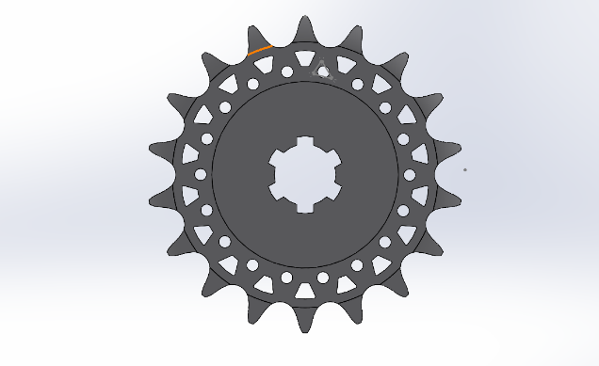
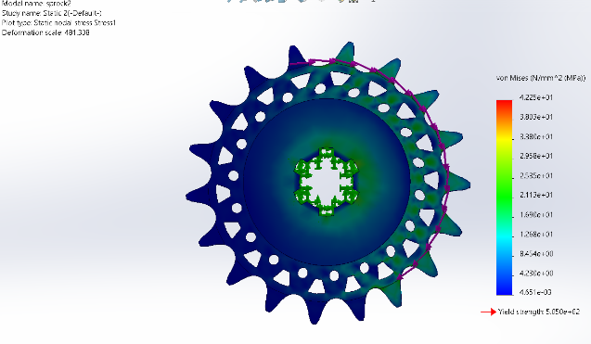
30-toothed Sprocket
Parameter | values
No.of teeth | 30
Chain Pitch | 12.7mm
Pitch Diameter | 60.75mm
Root Diameter | 56.72mm
Outside Diameter | 64.2mm
Torque Capacity | 86Nm
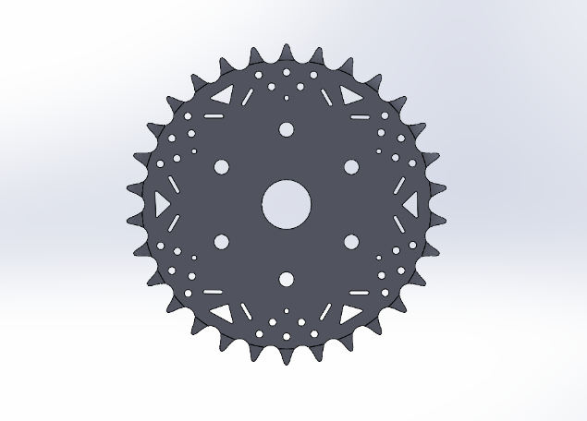

IV.Calculations
For 18-teeth sprocket
Given:
Number of Teeth, N = 18
Outer Diameter, OD = 39.82 mm
Pitch Diameter, PD = 36.30 mm
Root Diameter, RD = 32.00 mm
Material = 6082-T6 Aluminium Alloy
Yield Strength, σy = 260 MPa
Applied Torque, T = 51.6 N·m
Sprocket Thickness, t = 7.2 mm

1.Pitch Radius
r = PD / 2
r = 36.30 / 2
r = 18.15 mm
r = 0.01815 m

2.Tangential Force Acting on Sprocket
Ft = T / r
Ft = 51.6 / 0.01815
Ft = 2842.98 N
Ft = 2.84 kN

3.Load per Tooth
Assuming three teeth share the load:
Ftooth = Ft / 3
Ftooth = 2842.98 / 3
Ftooth = 947.66 N

4.Circular Pitch
p = (π × PD) / N
p = (3.1416 × 36.30) / 18
p = 6.34 mm

5.Tooth Contact Area
A = t × p
A = 7.2 × 6.34
A = 45.65 mm²

6.Bearing Stress on Tooth
σb = Ftooth / A
σb = 947.66 / 45.65
σb = 20.76 MPa

7.Factor of Safety
FoS = σy / σb
FoS = 260 / 20.76
FoS = 12.52

RESULTS
Pitch Radius = 18.15 mm
Tangential Force = 2842.98 N
Load per Tooth = 947.66 N
Circular Pitch = 6.34 mm
Contact Area = 45.65 mm²
Bearing Stress = 20.76 MPa
Yield Strength = 260 MPa
Factor of Safety = 12.52

For 30-teeth sprocket
Given:
Number of Teeth, N = 30
Chain Pitch = 12.7 mm
Pitch Diameter, PD = 60.75 mm
Root Diameter, RD = 56.72 mm
Outside Diameter, OD = 64.20 mm
Material = 6082-T6 Aluminium Alloy
Yield Strength, σy = 260 MPa
Applied Torque, T = 86 N·m
Sprocket Thickness, t = 7.2 mm

1.Pitch Radius
r = PD / 2
r = 60.75 / 2
r = 30.375 mm
r = 0.030375 m

2.Tangential Force Acting on Sprocket
Ft = T / r
Ft = 86 / 0.030375
Ft = 2831.28 N
Ft = 2.83 kN

3.Load per Tooth
Assuming three teeth share the load:
Ftooth = Ft / 3
Ftooth = 2831.28 / 3
Ftooth = 943.76 N

4.Circular Pitch
p = (π × PD) / N
p = (3.1416 × 60.75) / 30
p = 6.36 mm

5.Tooth Contact Area
A = t × p
A = 7.2 × 6.36
A = 45.79 mm²

6.Bearing Stress on Tooth
σb = Ftooth / A
σb = 943.76 / 45.79
σb = 20.61 MPa

7.Factor of Safety
FoS = σy / σb
FoS = 260 / 20.61
FoS = 12.62

RESULTS
Pitch Radius = 30.375 mm
Tangential Force = 2831.28 N
Load per Tooth = 943.76 N
Circular Pitch = 6.36 mm
Contact Area = 45.79 mm²
Bearing Stress = 20.61 MPa
Yield Strength = 260 MPa
Factor of Safety = 12.62

